Gateway Christian School

Warrior Football Schedule
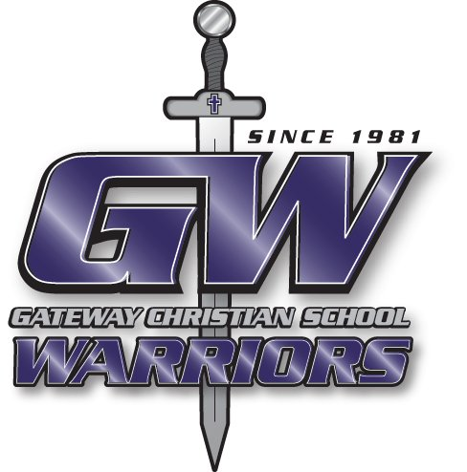
2024

Junior High
Friday, August 23 | Cloudcroft | Home | 4:00 pm
Thursday, September 5 | Hagerman | Home | 4:00 pm
Friday, September 27 | Mescalero | Home | 4:00 pm
Friday, October 4 | Melrose | Home | 4:00 pm
Friday, October 11 | Tatum | Away | 4:00 pm
Friday, October 25 | Hagerman | Away | 4:00 pm

Varsity
Friday, August 23 | Cloudcroft | Home | 7:00 pm
Friday, August 30 | Escalante | Away | 7:00 pm
Friday, September 6 | Bye
Friday, September 13♦ | Lordsburg | Home | 6:00 pm
Friday, September 20 | Mesilla | Away | 7:00 pm
Friday, September 27 | Mescalero | Home | 7:00 pm
Friday, October 4 ♥ | Melrose | Home | 7:00 pm
Friday, October 11 | Tatum | Away | 7:00 pm
Friday, October 18 | Bye
Friday, October 25 | Hagerman | Away | 7:00 pm
Friday, November 1 | Quarterfinals | TBA | TBA
Friday, November 8 | Semifinals | TBA | TBA
Saturday, November 16 | State Finals | TBA | TBA

♦Homecoming
♥Parent’s Night

Superintendent: Rick Rapp
JH/HS Principal: Justin Stephens
AthleticDirector: Justin Stephens

Head Coach: Shaun Wigley
Offensive Coordinator: Gilbert Lucero
Defensive Coordinator: Aarmon Guillen
Assistant Coach: Jerry Kermode, David Aguilar
Assistant Coach: Justin Stephens, Larry Luna

Gateway Christian School
575-622-9710
gatewaychristianschool@gatewaychristianschool.us

Gateway Church
Pastor: Rick Rapp
575-623-8670
gateway@gatewaychurchroswell.com

