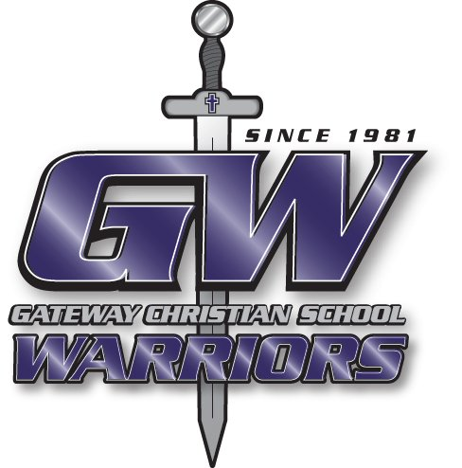
Gateway Christian Warrior Track 2025
Date | Meet | Team | Site
Friday, February 21 | All Saints | Junior High | GCS
Friday, February 28 | RISD | Varsity | Wool Bowl
Saturday, March 8 | Bulldog Relays | Varsity | Artesia
Tuesday, March 11 | Roswell MS | Junior High | Wool Bowl
Friday, March 14 | RISD JV | Varsity | Wool Bowl
Tuesday, March 25 | Little Demon | Junior High | Dexter
Friday, March 28 | Dexter | Varsity | Dexter
Friday, April 11 | Alfalfa Relays | Varsity | Hagerman
Saturday, April 19 | Fox & Vixen | Varsity | Fort Sumner
Tuesday, April 22 | Capitan | Junior High | Capitan
Friday, April 25 | City Meet | Varsity | Wool Bowl
Saturday, May 3 | District | Varsity | Fort Sumner
Friday & Saturday May 9-10 | State Meet | Varsity | Albuquerque

Superintendent: Rick Rapp Coaches: Perry Toles
JH/HS Principal: Justin Stephens Jack Batson

Athletic Director: Justin Stephens Savanna Fox

James Kelt

